# ****Adaptive Image Thresholding | Computer Vision | Python****

[[Kazi Mushfiqur Rahman](https://medium.com/@KaziMushfiq1234?source=post_page-----1a673eede182--------------------------------)](https://medium.com/@KaziMushfiq1234?source=post_page-----1a673eede182--------------------------------)

[Kazi Mushfiqur Rahman](https://medium.com/@KaziMushfiq1234?source=post_page-----1a673eede182--------------------------------)

·

[Follow](https://medium.com/m/signin?actionUrl=https%3A%2F%2Fmedium.com%2F_%2Fsubscribe%2Fuser%2F16ea6542ad64&operation=register&redirect=https%3A%2F%2Fmedium.com%2F%40KaziMushfiq1234%2Fadaptive-thresholding-of-image-computer-vision-python-1a673eede182&user=Kazi+Mushfiqur+Rahman&userId=16ea6542ad64&source=post_page-16ea6542ad64----1a673eede182---------------------post_header-----------)

3 min read

·

Dec 2

5



Photo by [Hasanul Banna](https://unsplash.com/@halbanna?utm_source=medium&utm_medium=referral) on [Unsplash](https://unsplash.com/?utm_source=medium&utm_medium=referral)

**Source code in GitHub**

## [opencv-app/image thresholding at main · mushfiq1998/opencv-app](https://github.com/mushfiq1998/opencv-app/tree/main/image%20thresholding?source=post_page-----1a673eede182--------------------------------" \t "_blank)

### [Contribute to mushfiq1998/opencv-app development by creating an account on GitHub.](https://github.com/mushfiq1998/opencv-app/tree/main/image%20thresholding?source=post_page-----1a673eede182--------------------------------" \t "_blank)

[github.com](https://github.com/mushfiq1998/opencv-app/tree/main/image%20thresholding?source=post_page-----1a673eede182--------------------------------" \t "_blank)

In simple thresholding techniques we were setting our global value of threshold.



Here, 127 is the global value of threshold. This means that it is same for all the pixels in image.

**Now we will learn how to use adaptive thresholding in image?**

Adaptive thresholding is the method where the threshold value is calculated for the smaller region. So the threshold is not global for every pixel, but it is calculated for smaller region. And therefore there will be different threshold value for different region.

**Why we need adaptive thresholding?**

Using simple thresholding might not be good idea in all the conditions. So there might be conditions where the image has different lighting conditions in different regions. And in those cases where the lighting conditions in the images varies from point to point. In those cases we might want to use adaptive thresholding. So as I said adaptive thresholding calculates the threshold for a smaller region of images. we get different thresholding values for different regions of the same image. And as a result adaptive thresholding gives us better result for images with varying elimination

**Start with adaptive thresholding**

**start\_adaptive\_thresh.py**

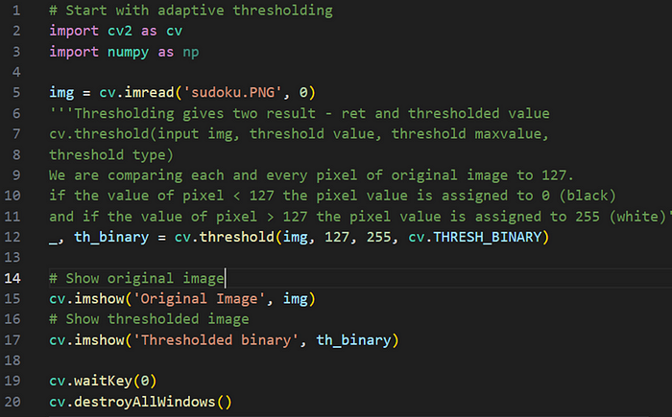

**Output**

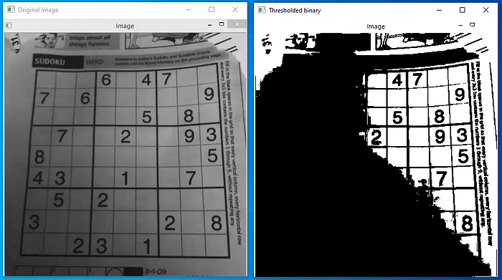

**Adaptive thresholding**

There are two types of thresholding methods: ADAPTIVE\_THRESH\_MEAN\_C and ADAPTIVE\_THRESH\_GAUSSIAN\_C

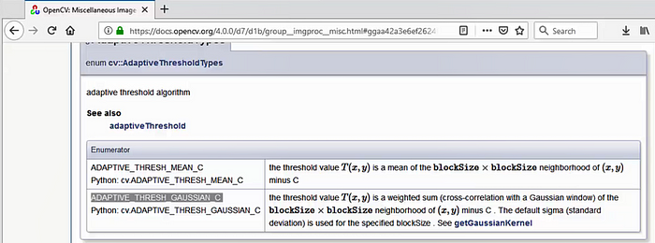

**adaptive\_thre.py**

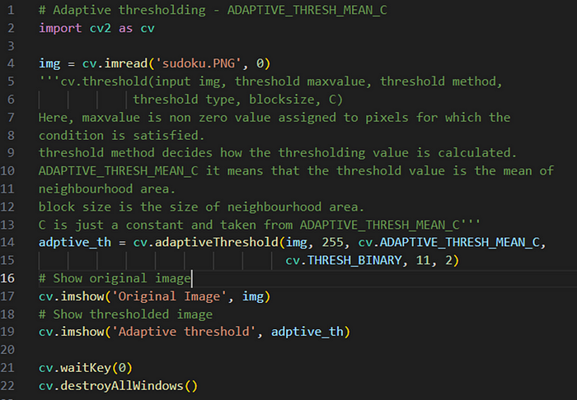

**Output**

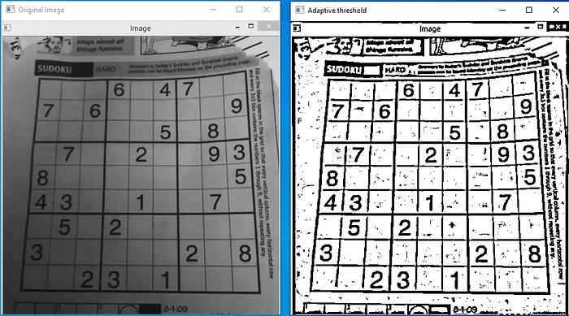

**Adaptive thresholding using the method ADAPTIVE\_THRESH\_MEAN\_C with THRESH\_BINARY**

**adaptive\_thre\_with\_binary.py**

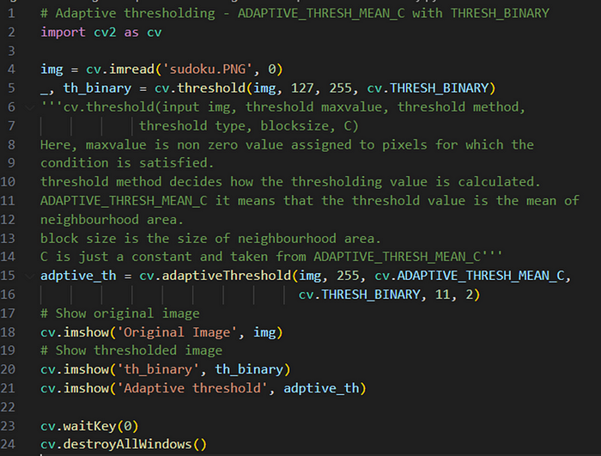

**Output**

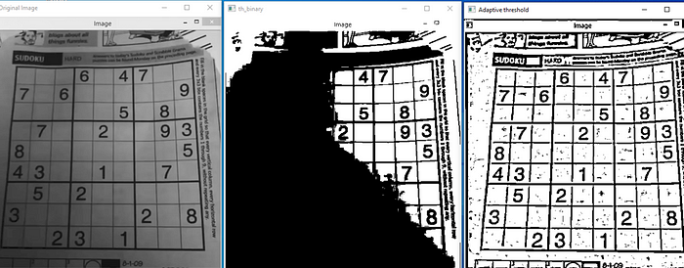

**Adaptive thresholding using the method ADAPTIVE\_THRESH\_GAUSSIAN\_C**

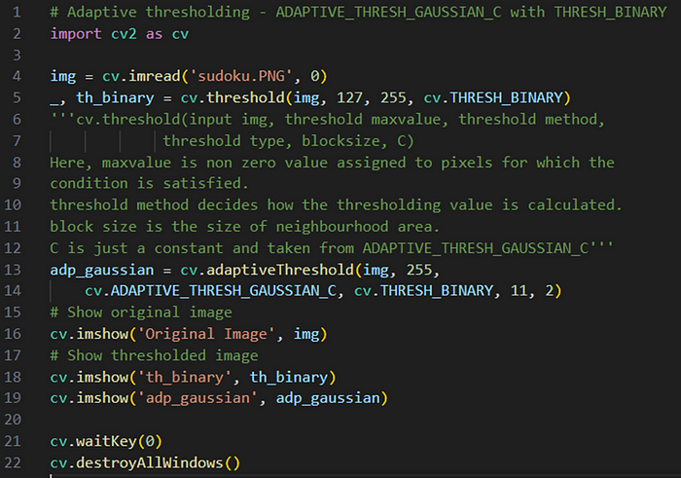

**Output**

